# Very High Resolution Mapping of Spekboom Canopy Cover

# Abstract

Very high resolution canopy cover maps of Spekboom (*Portulacaria afra*) are required to assist with restoration of degraded habitat in the Little Karoo, a large semi-arid region in South Africa. There have been relatively few studies addressing high resolution remote sensing of vegetation over large spatial extents, especially in arid areas. Variations in habitat and level of degradation, in addition to radiometric variations in the imagery, make this a challenging problem. Here we present a per-pixel classification approach for canopy cover mapping of Spekboom. Multi-spectral 0.5m resolution aerial imagery, comprising 2228 scenes covering a 5893 km2 area, was acquired from Chief Directorate: National Geospatial Information. The imagery was corrected with a novel technique for the extraction of surface reflectance by calibration with satellite data. Ground truth was produced by selecting and hand labelling polygons in the imagery. A feature clustering and ranking procedure that is robust to feature redundancy was applied to select an informative feature subset from a typical set of spectral, textural and vegetation index features. Support Vector Machine (SVM), random forest, decision tree, K-Nearest Neighbour (kNN) and Bayes normal classifiers were evaluated against both the hand labelled image ground truth and canopy cover ground truth acquired at 20 field sites. All classifiers except the Bayes normal classifier performed similarly well. The decision tree produced the best results on the field ground truth and was chosen as the final classifier. It produced a mean absolute canopy cover error of 5.85% with a standard deviation of 4.65% on the field ground truth.

## Index Terms: Very high resolution, aerial, vegetation mapping, classification, radiometric correction, feature redundancy

# Introduction

Spekboom (*Portulacaria afra*) is an evergreen succulent tree growing to 2.5m, with a dense canopy of small fleshy leaves. It occurs in the Subtropical Thicket biome in the semi-arid Eastern Cape and Little Karoo regions in South Africa (Vlok et al., 2005). “The Subtropical Thicket habitat types are most easily recognized by the occurrence of woody trees, spinescent shrubs and a relative abundance of succulents. When occurring as solid stands the vegetation can form impenetrable dense thickets, but this is uncommon in the Little Karoo. In most of the area the Subtropical Thicket vegetation occurs as discrete bush-clumps, usually in a matrix of Succulent Karoo vegetation” (Vlok, Cowling & Wolf 2005: 41). While Spekboom is tolerant of browsing by indigenous herbivores, it is highly susceptible to over browsing by goats (Marais et al., 2009; Mills et al., 2007, 2005; Sigwela et al., 2009). Poorly managed goat grazing has transformed thicket over much of its range into sparsely scattered thicket clumps, isolated trees and a covering of herbs (Mills et al., 2005).

Restoration of degraded thicket habitat is beneficial from a number of perspectives. Spekboom is unusually effective at storing carbon for an arid region (Mills et al., 2005). Subtropical Thicket provides an important source of food for many herbivores, including domesticated livestock (Thompson et al., 2009; Vlok et al., 2005). Re-establishment of Spekboom in degraded areas will reduce erosion, reduce flood severity and improve water quality (Mills and Cowling, 2006; van Luijk et al., 2013). It is also attractive from an employment perspective; potentially creating thousands of jobs in impoverished areas, if implemented on a large scale.

Currently, the most practical option for thicket ecosystem restoration is through the planting of Spekboom cuttings (Mills et al., 2007; Vyver et al., 2012). The dense canopy of Spekboom facilitates an accumulation of soil organic matter which in turn significantly improves the water-holding capacity and fertility of the soil (Adie and Yeaton, 2013; Lechmere-Oertel et al., 2008; Mills and Cowling, 2010; Mills and Fey, 2004). The provision of shade, improved soil quality and moisture retention, creates a favourable environment for spontaneous recruitment of other plants (Adie and Yeaton, 2013; Mills and Cowling, 2010). Observations at two Spekboom restoration sites showed that over a period of 40 to 50 years, woody canopy and other species re-established such that the composition of the restored thicket approximated that of intact thicket (van der Vyver et al., 2013).

Spekboom canopy cover maps are required to assist in the restoration process. There is a need for greater accuracy and repeatability than is possible with field based mapping techniques. Field mapping is time consuming and costly and is not practical on a large scale (Eisfelder et al., 2012; Lu, 2006; Powell, 2009). The impracticality of manual field mapping is confounded in the Subtropical Thicket biome due to its density, heterogeneous nature and complex growth forms (Powell, 2009). One of the factors informing the identification of candidate restoration areas is the level of degradation. This can be estimated from the existing canopy cover and measures of intact canopy cover in a similar habitat to the restoration area. Measures of intact canopy cover also provide a guide as to an appropriate planting density. Restoration progress can be monitored by updating the canopy cover map over time. Canopy cover represents a first step towards being able to remotely sense biomass (Eisfelder et al., 2012; Ludwig et al., 1975; Suganuma et al., 2006), which would assist in the carbon accounting required for trading credits on the international market (Mills et al., 2010).

Thompson et al. (2009) conducted a degradation mapping study in the Little Karoo. A detailed 1:50000 vegetation map of the Little Karoo developed by Vlok, Cowling & Wolf (2005), was used to delineate different habitats so they could be treated separately. The degradation levels of Subtropical Thicket were derived by thresholding MODIS NDVI data. North and south facing slopes were treated separately to account for the different densities of Spekboom in these topographies. To exploit the relative greenness of Spekboom compared to the background vegetation, data from the September growing season was used for the thresholding. This NDVI data was averaged over two years. The study was successful at estimating intact, moderate and severe degradation levels of Spekboom thicket at the MODIS resolution of 250m.

Currently, there is an initiative to involve private land-owners in restoration in order to broaden its impact (Curran et al., 2012; Mills et al., 2010). Maps at a pixel resolution of 1.5m or smaller are required to provide sufficient spatial detail for working with expected stand sizes of the order of 50 hectares. High spatial resolution imagery is also necessary to facilitate discrimination of small Spekboom clumps from the complex and varying mosaic vegetation in which it occurs. To achieve sufficient accuracy for carbon storage estimations, it will be necessary to estimate canopy cover in finer detail than the three levels of degradation used in Thompson et al. (2009).

Multi-spectral VHR imagery has been successfully used for vegetation mapping in a number of studies. Approaches based on the classification of segmented image objects (object based image analysis (OBIA)) are popular (Basu et al., 2015; Ghosh and Joshi, 2014; Johansen et al., 2007; Kollár et al., 2013; Mustafa and Habeeb, 2014; Ouyang et al., 2011) and are found to slightly outperform pixel based approaches (Ghosh and Joshi, 2014; Ouyang et al., 2011). Per pixel classification nevertheless provides good and useful mapping accuracy in a number of studies (Boyden et al., 2007; de Castro et al., 2012; Mehner et al., 2004) and is a simpler and faster method; not requiring expensive, proprietary segmentation software. A combination of spectral, vegetation index, band ratio and textural features are commonly used to provide informative measures capable of distinguishing vegetation classes (Basu et al., 2015; Ghosh and Joshi, 2014; Johansen et al., 2007; Kollár et al., 2013; Mustafa and Habeeb, 2014).

Ranking features based on some separability or importance measure of individual features is commonly used as a feature selection method (Basu et al., 2015; Johansen et al., 2007; Kollár et al., 2013). While fast, feature ranking is known to be sub-optimal for feature spaces containing redundancy (Tolosi and Lengauer, 2011). Ghosh and Joshi (2014) used recursive feature elimination (RFE) (also known as backward elimination); a greedy search technique to select informative features. Of the reviewed studies, this was the only one to use a feature selection method that considers the effect of feature redundancy by evaluating features in combination. A variety of supervised approaches are used for classification of features derived from VHR imagery. Some authors found the Bayes normal (maximum likelihood (ML)) classifier to adequately model their class distributions (Boyden et al., 2007; de Castro et al., 2012; Mehner et al., 2004). Others adopted more sophisticated approaches such as support vector machines (Ghosh and Joshi, 2014) and neural networks (Basu et al., 2015; Mustafa and Habeeb, 2014). Proprietary algorithms implemented in the eCognition software package (Trimble, 2016) are also frequently used for VHR image classification (Johansen et al., 2007; Kollár et al., 2013; Ouyang et al., 2011).

The majority of the reviewed vegetation mapping studies were applied to small areas, typically covered by a single satellite image (Boyden et al., 2007; Ghosh and Joshi, 2014; Johansen et al., 2007; Kollár et al., 2013; Mehner et al., 2004; Ouyang et al., 2011). Radiometric corrections are sometimes ignored for small study areas (Boyden et al., 2007) or partially handled using conversion to top of atmosphere (TOA) radiance (Johansen et al., 2007; Mehner et al., 2004). These corrections do not compensate for varying atmospheric and bi-directional distribution function (BRDF) effects that are characteristic of studies containing hundreds or thousands of aerial images, such as ours.

In this paper, we present a method for mapping Spekboom canopy cover at a spatial resolution of 0.5m using multi-spectral aerial imagery. Images of the study area were compensated for coarse-scale atmospheric and BRDF effects using a simple yet effective technique for conversion to surface reflectance. Correction to an absolute property of the surface, like surface reflectance, opens the possibility of extending the presented mapping technique spatially and temporally. An informative feature subset was selected from a typical set of spectral, vegetation index and textural features using a novel feature selection method that is robust to redundancy typically found in high dimensional feature sets. The selected features were used to evaluate a set of candidate classifiers. A decision tree was selected as the final classifier and shown to be accurate on both hand-labelled image and field collected ground truth.

While commercially available remote sensing tools (ENVI, PCI Geomatica, eCognition etc.) are often used for VHR segmentation and classification tasks, these tools are costly and do not scale well to thousands of images (Basu et al., 2015). Given the large number of images and budget constraints, both cost and computation time were important considerations in the formulation of our method. Custom image pre-processing and classification software tools were developed using freely available, open source libraries. Careful consideration was given to computational efficiency in the selection of features and classification algorithm.

# Methods

## Study Area

The Little Karoo as defined in Vlok, Cowling & Wolf (2005), is a semi-arid region of great biodiversity lying between two mountain ranges. Three biomes considered to be biodiversity hotspots of global significance intersect in the Little Karoo (Thompson et al., 2009). 54 habitat types were identified by Vlok, Cowling & Wolf (2005) in their vegetation map, of which ten support Spekboom. The Subtropical Thicket biome makes up 35.3% of the Little Karoo which has a total area of 2 343 900 ha (Vlok et al., 2005). It was found that 89.3% of the Spekboom thicket was degraded to some extent in an area comprising roughly half of the Little Karoo (Thompson et al., 2009). The Little Karoo is an interesting study area because it contains a significant portion of Spekboom suited and degraded habitat and has been targeted for restoration. A 5893 km2 representative portion was chosen as the study area, as shown in Figure 1. This area includes examples of all the different biomes and nine of the ten habitat types supporting Spekboom as defined by Vlok, Cowling & Wolf (2005). Figure 2 shows a study area map of the different habitats supporting Spekboom.

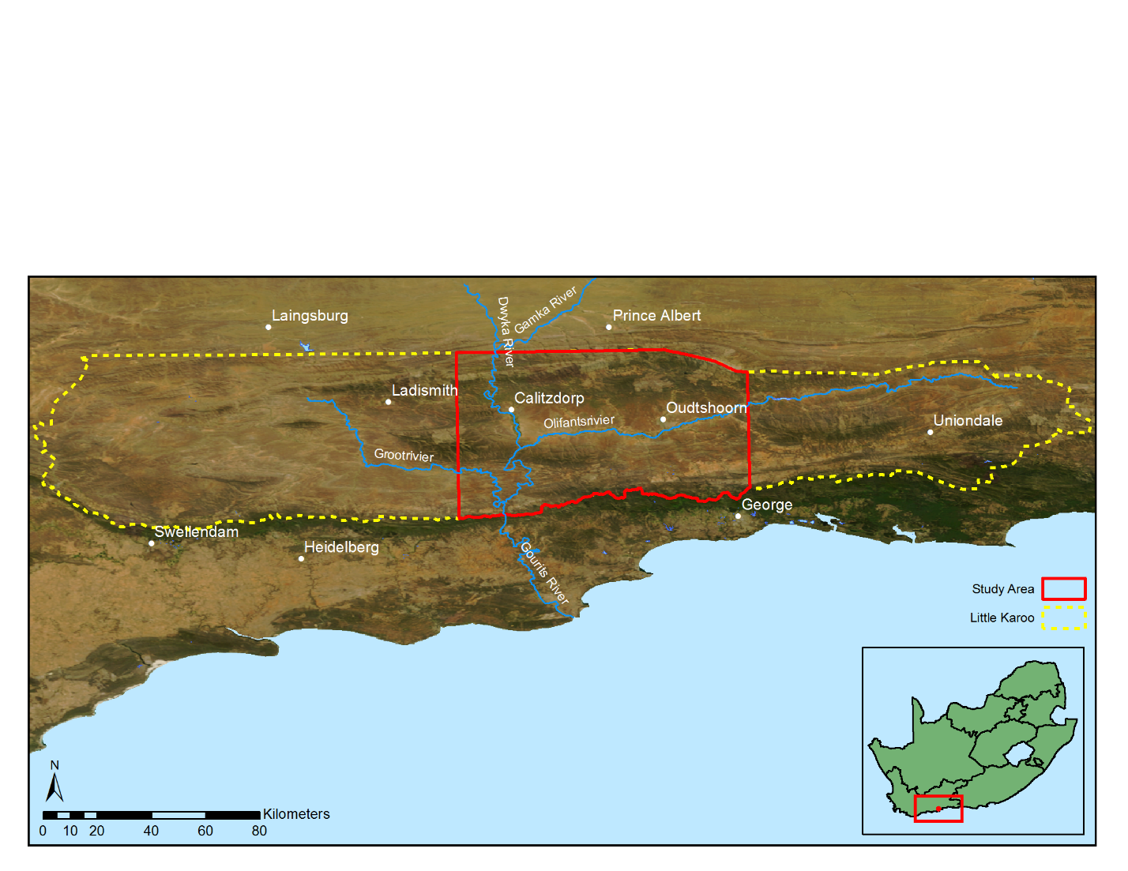

Figure 1 Little Karoo study area

## Data and Ground Truth

We acquired VHR aerial imagery of the study area from Chief Directorate: National Geo-spatial Information (NGI), a component of the South African Department of Rural Development and Land Reform. The images are captured at a 0.5m/pixel resolution with an Intergraph DMC camera which provides multi-spectral red, green, blue and near-infrared (NIR) bands. The imagery for our study area consists of 2228 images acquired over multiple days from 22 January to 8 February 2010. While the imagery provided by NGI is orthorectified, it has no radiometric corrections applied to it. The NGI imagery contains significant variations due to BRDF and atmospheric effects which make it poorly suited to quantitative remote sensing techniques. We radiometrically corrected the aerial imagery using a technique for the extraction of surface reflectance by calibration with satellite data. This technique corrects for coarse scale atmospheric and BRDF effects using a well-calibrated satellite surface reflectance image as a reference. We used a MODIS MCD43A4 composite image for the period from 25 January 2010 to 9 February 2010 for the surface calibration reference. This image has a 500m resolution and contains nadir BRDF-adjusted reflectance (NBAR) data composited from the best values over a 16 day period. Further details of the technique and its application to the study area can be found in Chapter 2. Radiometric correction is important for our study as it allows accurate snapshot mapping over a large spatial area as well as provides the possibility of repeating the canopy cover mapping over time to evaluate restoration progress.

Canopy cover ground truth was acquired in the field at 20 different sites, each of roughly one hectare. A botanist with significant experience in the area provided expertise in the selection of sites to encompass variation in geology, habitat and level of degradation. Boundary polygons, were recorded for each site by walking the perimeter with a DGPS device. These were post-processed to provide sub one meter accuracy. Estimates of canopy cover inside the polygons were established visually and reference photos captured. The locations of the ground truth sites and their corresponding area names are shown in Figure 2. Details of the mosaic vegetation, geology and measured canopy cover for each site are given in Table 1. A three level degradation measure, as used in Thompson et al. (2005), is reported for each site. The canopy cover measures were made in the field as a range between minimum and maximum values, spanning at most ten percent. The midpoint between these minimum and maximum values is reported in Table 1. This data set is referred to as the “field ground truth”. Figure 3 shows an example of a ground truth polygon on a background of the NGI imagery, rendered in RGB.

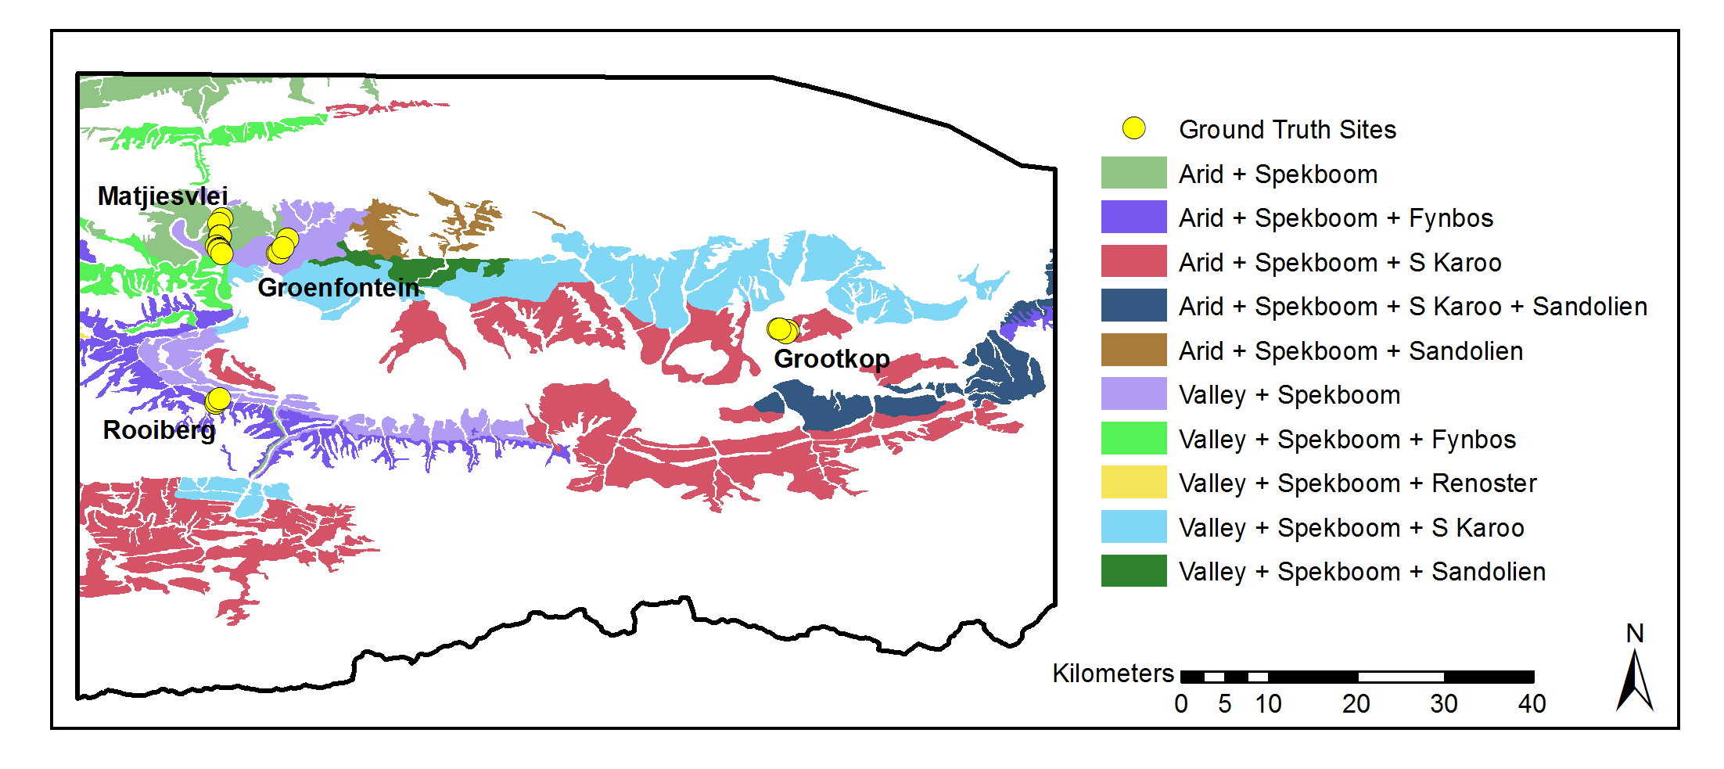

|  |  |
| --- | --- |
| Figure 2 Study area Spekboom habitats and field ground truth sites | Source: (Vlok et al., 2005) |

Table 1 Field ground truth site information

|  |  |  |  |  |  |
| --- | --- | --- | --- | --- | --- |
| Area | Number | Geology | Mosaic | Degradation | Cover (%) |
| Matjiesvlei | 1a | Shale | Arid Spekboom | Pristine | 6.0 |
|  | 1b |  |  | Pristine | 22.5 |
|  | 2 |  |  | Pristine | 70.0 |
|  | 3 |  |  | Pristine | 85.0 |
|  | 4 |  |  | Pristine | 65.0 |
|  | 5 |  |  | Pristine | 37.5 |
|  | 6 |  |  | Pristine | 17.5 |
|  | 7 |  |  | Pristine | 15.0 |
|  | 8 |  |  | Pristine | 2.0 |
| Groenfontein | 1 | Shale | Arid Spekboom | Severe | 0.0 |
|  | 2 |  |  | Severe | 4.0 |
|  | 3 |  |  | Severe | 10.0 |
|  | 4 |  |  | Moderate | 25.0 |
| Grootkop | 1 | Enon Conglomerate | Succulent Karoo | Pristine | 22.5 |
|  | 2 |  |  | Severe | 0.5 |
|  | 3 |  |  | Moderate | 42.5 |
|  | 4 |  |  | Pristine | 77.5 |
| Rooiberg | 1 | Sandstone | Fynbos | Pristine | 20.0 |
|  | 2 |  |  | Moderate | 11.0 |
|  | 3 |  |  | Severe | 0.0 |

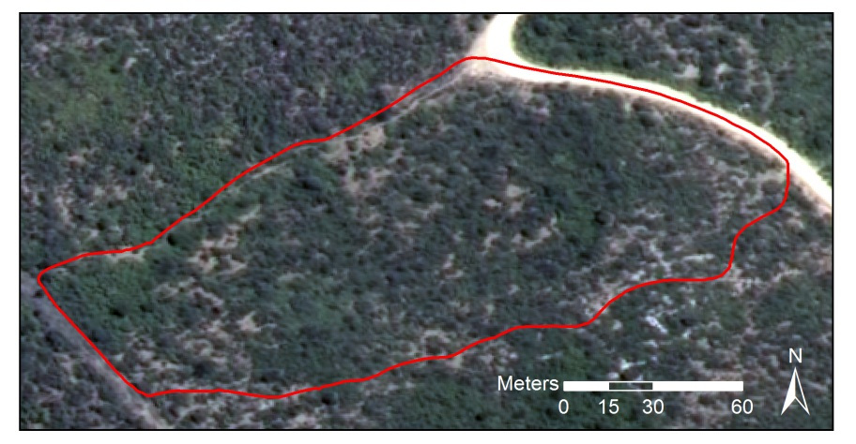

Figure 3 Matjiesvlei2 ground truth site

Table 2 Class descriptions

|  |  |
| --- | --- |
| Class Name | Description |
| Spekboom | Spekboom |
| Tree | Any recognisable tree but especially the darker *Euclea* and *Pappea* trees commonly found intermingled in stands of Spekboom. |
| Background | Bare ground, small shrubs, herbs and anything else not included in the first two classes. |

We adopted a labelling scheme of three classes as described in Table 2. While canopy cover mapping is in essence a two class problem (Spekboom and everything else), the addition of the third Tree class was beneficial. By merging multiple classes into a single class, the ability to adjust the priors of individual merged classes is lost. The class priors, or “weights”, control the relative emphasis the classifier places on identifying each class correctly (Mingguo et al., 2009). The differentiation of Spekboom from trees is a particularly challenging part of the problem due to their spectral and textural similarity. Thus the addition of the Tree class is useful, as it allows control over the classification accuracy of trees relative to the other classes. The descriptive power or complexity of the classifier is also improved by including the extra class. By modelling three classes, the ability of the classifier to approximate complex decision boundaries is improved, especially in the vicinity of the problematic Tree - Spekboom overlap.

Classifier training data was obtained by visual discrimination and hand labelling of images. RGB and CIR images were used side by side in this exercise. Objects belonging to the various classes were delineated with polygons as shown in Figure 4. Only objects where there was a reasonable degree of confidence of class membership were included in the ground truth. Despite this, it is unavoidable that the ground truth contains some inaccuracies as it is not always easy to visually distinguish between the different classes. Areas were selected to encompass variability in habitat and level of degradation. This ground truth was selected from the four images containing the field ground truth of Table 1. The total number of polygons and pixels ground truthed for each class is shown in Table 3. This data set is referred to as the “image ground truth”.



Figure 4 Hand labelled ground truth

Table 3 Image ground truth size

|  |  |  |
| --- | --- | --- |
| Class Name | Polygons | Pixels |
| Spekboom | 52 | 27260 |
| Tree | 64 | 3357 |
| Background | 44 | 182044 |
| **Total** | **160** | **212661** |

## Mapping Methodology

We followed a statistical pattern recognition approach to classify Spekboom canopy. Our pixel size of 0.5m, combined with the tendency of Spekboom to grow in continuous stands meant that there was little spectral mixing and pixels covering Spekboom were relatively pure. This supported a hard per-pixel classification approach as opposed to a soft classification (Xu et al., 2005) or regression type approach that is often used in biomass estimation (Eisfelder et al., 2012; Lu, 2006). The fractional canopy cover was then determined as the portion of pixels classified as Spekboom over an area of interest. Object based approaches to image classification, where homogenous objects are first segmented and then classified as a whole, have become popular. These approaches are often favoured for VHR imagery because they are potentially able to better exploit the additional spatial information and deal with unwanted variation when compared to the more traditional per-pixel approach (Ghosh and Joshi, 2014; Ouyang et al., 2011). The segmentation problem is however recognised as being poorly posed, requiring manual adjustment of parameters and being difficult to solve robustly (Baraldi et al., 2010). We followed a pixel based approach as this gave us adequate accuracy and avoided the complexities and computation time associated with segmentation. Some vegetation has distinctive phenological variations which can be a useful source of information in distinguishing different species or measuring characteristics of a habitat such as degradation (Thompson et al., 2009). We were limited to a snapshot approach as there was only one set of aerial imagery available for the study area from NGI at the time of writing.

## Features

Spekboom has a characteristic lime green colour and is evergreen. The NGI imagery was captured in January, which is in the Little Karoo’s dry season. This helped contrast the evergreen Spekboom against the comparatively drier background vegetation. In a relatively undisturbed state, it grows in clumps consisting of many shrubs, interspersed with occasional trees such as *Pappea* and *Euclea*. A set of 46 features that would aid in describing these visual characteristics of Spekboom were evaluated. The set included a fairly typical combination of spectral features, vegetation indices and texture features. Similar features have been used in Li et al. (2010) and Trias-Sanz, Stamon & Louchet (2008).

The features we used can be separated into two broad categories: per-pixel and sliding window features. The per-pixel features are found with the spectral information from only that pixel, while the sliding window features are found from some statistic or function of the pixels inside a small local neighbourhood. While the spectral resolution of the VHR imagery is poor, the spatial resolution allows description of vegetation structure and spatial patterns that is not possible with lower resolution satellite imagery. Texture is recognised as an important feature in biomass estimation in complex habitats (Lu, 2006; Singh et al., 2014). The sliding window features were included to try and exploit this source of information in distinguishing our classes. We did not include common texture features such as statistics of the Gray Level Co-occurrence Matrix (GLCM) or the occurrence histograms of Local Binary Patterns (LBP). To be representative, these texture features need to be calculated from a greater number of pixels than is practical with a small sliding window. Typically they are evaluated per region and thus require an object based approach. A cross validated grid search was used to select the size of the sliding window, with the accuracy of a naïve Bayes classifier trained on the EntropyPc1 feature as the performance criterion.

The colour of an object is defined by the shape of its reflectance spectrum while the intensity is defined by the spectral amplitude. The dimensions of the raw RGB colour space are coupled with intensity. Colour is captured by the relative amounts of the raw colour bands rather than their absolute values. Normalised colour features are defined by (Blauensteiner et al., 2006):

|  |  |  |  |  |
| --- | --- | --- | --- | --- |
| $$c_{i}^{n}=\frac{C_{i}}{\sum_{i=1}^{4}{C_{i}}}$$ |  |  |  | (1) |

Where $C_{i}$ are the raw R, G, B and NIR band values and $i$ is the band number. The denominator normalises for intensity. While we have calibrated the imagery to surface reflectance, this was done at a coarse spatial scale and radiometric variations remain at a fine resolution. This normalised colour space will assist in further removing intensity variations not removed by the surface reflectance correction.

Green, living vegetation absorbs light in the Photosynthetically Active Radiation (PAR) region of the spectrum which corresponds to the red band. There is a sharp transition from absorption to reflection around 700nm (Gates, 1980). Vegetation is highly reflective in the near infra-red band as the energy in these wavelengths is insufficient for photosynthesis and potentially harmful due to its heating effects. Various vegetation indices exploit these spectral properties. The Ratio Vegetation Index (RVI) is given by:

|  |  |  |
| --- | --- | --- |
| $$RVI=\frac{NIR}{R}$$ |  | (2) |

It has a range of zero to infinity and increases as the vegetation becomes denser and photosynthetically more active (Myneni et al., 1995). The well-known Normalised Difference Vegetation Index (NDVI) is defined as

|  |  |  |
| --- | --- | --- |
| $$NDVI=\frac{NIR-R}{NIR+R}$$ |  | (3) |

NDVI is limited to the range -1 to 1 and contains the same information as RVI but is easier to visualise and interpret due to its limited range. Both indices are invariant to intensity changes.

The tasselled cap transform is a linear transform of the raw band feature space to a new orthogonal co-ordinate system, similar to a principal component transform. It was designed for agricultural wheat classification and was intended to reduce variability in soil and wheat classes by removing variation due to topography, sun angle and wheat growth stage (Kauth and Thomas, 1976). The tasselled cap transform was approximated for our problem using a principal component transform derived from the variance of the Spekboom class. This way the first component was aligned with Spekboom variation rather than wheat variation as in the original tasselled cap transform. As it is simply a rotation of the raw band space, its usefulness is as a dimensionality reduction technique similar to PCA, rather than as an extractor of novel features. The principal components of the normalised colours of Equation (1) were also included.

Entropy is a statistic that describes the amount of randomness in a variable. It was included in our feature set as a texture feature to describe complexity in the local neighbourhood of a sliding window. The entropy of the values in the image window $x$ is defined by (Trias-Sanz et al., 2008):

|  |  |  |  |
| --- | --- | --- | --- |
| $$E(x)=-\sum_{i}{h_{i}(x)}\log_{2}{h_{i}(x)}$$ |  |  | (4) |

Where $h_{i}(x)$ is the probability in the $i^{th}$ histogram bin of $x$. 256 bins were used in all cases.

In addition to the entropy, the median and the four central moment features (mean, standard deviation, skewness and kurtosis) of Li et al. (2010) were included as sliding window features. The first principal component, RVI, NDVI and normalised green channel were all used as inputs to the sliding window feature set. The complete feature set and their labels are listed below in Table 4.

Table 4 Features

|  |  |  |
| --- | --- | --- |
| No. | Name | Description |
| 1 | R | Red |
| 2 | G | Green |
| 3 | B | Blue |
| 4 | NIR | Near-infrared |
| 5 | rN | Normalised R |
| 6 | gN | Normalised G |
| 7 | bN | Normalised B |
| 8 | nirN | Normalised NIR |
| 9 | NDVI | Normalised Difference Vegetation Index |
| 10 | RVI | Ratio Vegetation Index |
| 11-14 | tc1-4 | Tasselled cap components |
| 15-18 | pc1-4 | Principal components of raw bands |
| 19-22 | nc1-4 | Principal components of normalised bands |
| 23-26 | Entropy## | Sliding window entropy of pc1, RVI, NDVI and gN |
| 27-30 | Std## | Sliding window standard deviation of pc1, RVI, NDVI and gN |
| 31-34 | Mean## | Sliding window mean of pc1, RVI, NDVI and gN |
| 35-38 | Median## | Sliding window median of pc1, RVI, NDVI and gN |
| 39-42 | Skewness## | Sliding window skewness of pc1, RVI, NDVI and gN |
| 43-46 | Kurtosis## | Sliding window kurtosis of pc1, RVI, NDVI and gN |

## Feature Selection

The raw bands of the NGI imagery have significant spectral overlap (Intergraph, 2008) and consequently are highly correlated with one another. This is a common property of aerial multi-spectral sensors. These correlated raw bands are the source data for all the derived features, and the derived feature definitions too contain some inter-dependencies. A number of authors have noted that feature redundancy can cause inconsistencies and sub-optimality in selected features when using standard approaches (Sahu and Mishra, 2011; Strobl et al., 2008; Tolosi and Lengauer, 2011; Yousef et al., 2007). Redundancy can be effectively dealt with using a feature extraction approach such as PCA but this requires computation of the full feature set. This is not practical in computationally demanding applications such as ours.

We used a feature ranking method, called feature clustering and ranking, which is robust to feature redundancy.

Feature clustering and ranking is described as follows:

1. Perform average-linkage hierarchical clustering (Szekely and Rizzo, 2005) of the feature set using the correlation coefficient as the dissimilarity metric.
2. Select a natural number of clusters containing high correlation by visual inspection of the dendrogram.
3. Rank each cluster’s importance by finding the value of a relevance criterion for each individual feature and then finding the median of the feature relevance values in the cluster.
4. Select a single feature from each of the *N* clusters having the best importance scores.

More detail on the method can be found in Chapter 3. The number of clusters, *N*, was chosen using a grid search with the final classifier accuracy as performance measure. In this study, we used the accuracy of a naïve Bayes classifier as the feature relevance criterion. The naïve Bayes criterion makes no assumptions about the form of the class distributions and can thus provide a generic measure of separability. It is simple, fast and recognised as being accurate for a variety of problems (Hand and Yu, 2001). To avoid biased accuracy estimates, all classifier accuracy evaluation, for feature relevance or selection of *N*, is done on unseen test data using a ten fold cross validation (Bishop, 2003). Major benefits of the cluster ranking method are its speed and that it allows hand-picking of the single features that represent each cluster. The flexibility to choose features allows the user to favour those features that are fastest to compute or perhaps to choose those features that are more readily understood.

## Classification

The canopy cover mapping accuracies of decision tree, random forest, Support Vector Machine (SVM), Bayes normal and k-Nearest-Neighbour (kNN) classifiers were evaluated.

A decision tree is a tree of binary decision nodes based on thresholds of different features. Data is recursively split at each branch node until a terminal is reached representing a class label (Breiman et al., 1984). Training is performed by a greedy procedure which iteratively adds nodes and selects features producing the best split for each node. Criteria used for choosing the best feature at each node include the information content, node purity and Fisher’s criterion (Jain et al., 2000). Overtraining is a concern and trees can be pruned in a post-training step to reduce variance. Decision tree execution is fast. They are known for their ease of interpretation and node decisions can help provide insight into the problem. Decisions are usually binary and based on a single feature. As a result, the decision boundary is comprised of stepwise sections parallel to the feature axes and is at best an approximation to the optimal boundary (Jain et al., 2000). Decision trees are flexible and broadly applied as they make no assumptions on the form of class distributions and can deal with categorical as well as continuous variables (Breiman et al., 1984).

Random forests are classifiers that use bootstrapped aggregation (bagging) (Breiman, 1996) of a large collection of decision tree classifiers. Each tree is trained on a bootstrapped version of the data set and the decision feature for each node is selected from a random subset of the full feature set (Breiman, 2001). The bootstrapping and random feature subsets help introduce variation amongst the base tree classifiers. The combination of uncorrelated decision trees has greater predictive power than any single one. Importantly, a random forest is not prone to overtraining. Random forests are also robust to mislabelled training data. Both training and execution are moderately demanding of computation time. The two main parameters for tuning a random forest are the number of trees and the number of features considered for each node.

The Support Vector Machine (SVM) has been something of a breakthrough in pattern recognition and has received widespread successful use in recent years (Amorós López et al., 2011; Li et al., 2010; Sahu and Mishra, 2011; Yousef et al., 2007). The SVM was first posed as the problem of maximising the margin from a two class linear decision boundary to the nearest objects, called “support vectors” (Burges, 1998). The decision boundary is determined only by the support vectors, not directly by features or generative descriptions of class distributions. The SVM minimises the Vapnik-Chervonenkis (VC) dimension, a measure of the complexity of the classifier. This is an important property of the SVM and explains how it effectively adapts its complexity to the data, is robust to overtraining and performs well in high dimensional feature spaces. The original formulation was extended to the case of overlapping multi-class problems using a penalty term with user-defined multiplier *C*, that punishes class overlap. Using the kernel trick, the linear SVM was further extended to allow modelling of non-linear decision boundaries (Burges, 1998). Different kernels such as polynomials or Radial Basis Functions (RBF) may be chosen to suit the given problem. In our evaluation, an RBF kernel was used for the SVM classifier. The training procedure is a quadratic optimisation problem which is computationally demanding. Execution is fast however as it only requires evaluation of the kernel function for the support vector – object vector pairs (Jain et al., 2000).

The Bayes normal classifier, sometimes referred to as the maximum likelihood (ML) classifier, assumes the classes are normally distributed. Mean and covariance parameters are estimated for each class from the data, usually with the maximum likelihood criterion. Bayes rule is then used to define the decision boundary (Duin and Tax, 2005).

The kNN classifier labels test objects by finding the mode of classes of the closest k training objects (Bishop, 2003). Any distance metric can be used for finding neighbours but the Euclidean distance measure is prevalent and was used in our study. This classifier is a useful benchmark as it almost always performs reasonably well, requires only one parameter and makes no assumptions about class distributions (Jain et al., 2000). It requires finding distances to the full training set however which can make execution very slow.

The classifiers were implemented with the OpenCV software library (Bradski, 2000). User supplied tuning parameters for these classifiers were found with cross-validated grid searches. Morphological operators (Serra and Soille, 1994) were applied as a post processing step to the classifier produced maps to remove noise and smooth boundaries. Assuming that the majority of Spekboom plants were big enough to cover more than one pixel, a morphological opening was applied to remove isolated Spekboom pixels. Following this, spurious wrinkles and holes in the Spekboom boundaries were removed with a morphological closing operation. The assumption here being that Spekboom typically grows in solid clumps and any real gaps in these clumps would be more than a pixel wide. These operations can be seen as a way of further incorporating spatial context into the classification.

## Validation

In common classification tasks, one is interested in classifying each object (e.g. pixel in our case) as accurately as possible. Thus classifier performance measures such as overall error rate are based on per-object accuracies. For canopy cover mapping, we are interested in estimating the portion (i.e. abundance) of Spekboom inside a certain area. These are not entirely the same objectives and there can be situations where a performance measure based on per-object accuracy is uncorrelated with a performance measure based on abundance estimation accuracy. This happens when errors between classes cancel each other out. For example it is possible to have the correct number of objects in each class and thus zero abundance estimation error but with many of the individual objects in the wrong class and thus poor per-object accuracy. One should bear this distinction in mind when evaluating classifiers for abundance estimation. Practically speaking however, a good per-object classifier will be a good abundance estimator and although a good abundance estimator is not necessarily a good per-object classifier, it seems unlikely that such situations would be encountered.

The per-pixel (per-object) performance of the candidate classifiers was evaluated on the selected features using the image ground truth data. The size of the Background class was reduced to be the same as the Spekboom class by taking a random subsample. This was done to expedite classifier training times. To avoid biased estimates of performance, ten fold cross validation was used for all classifier evaluation. The canopy cover (abundance estimation) performance of the classifiers was also tested, using the field ground truth. After applying the classifiers and morphological operations to the relevant images, canopy cover estimates were extracted from inside the field site polygons. These estimates were compared to the field ground truth values.

# Results and Discussion

## Feature Selection

It was found that the optimal sliding window size was sensitive to the choice of performance criterion and the data subset used for evaluation. It was apparent that the choice of window size was not of much significance however, as the change in separability of the data over the range of window sizes tested was negligible. A window size of five was selected. This size seems sensible as it is of the same order as the size of a small Spekboom clump.

The dendrogram showing the clustering of our feature set, is plotted in Figure 5. The line in red shows the correlation threshold value at which the feature clusters were extracted. This value was selected as a relatively stable point in the hierarchy and one where the correlation amongst features is strong.



Figure 5 Clustering of correlated features

Table 4.5 lists the clusters ordered by their importance, with their component features. This table reveals a number of interesting properties of the features. Firstly, it is clear that there is a significant redundancy amongst the features as we suspected. The correlation between raw R, G, B and NIR bands is surprisingly strong, likely due to strong coupling with intensity, and these are all grouped into a single cluster. While the definitions of the nirN, NDVI and RVI features are quite different, they are all describing the same spectral property of vegetation, namely high absorption in the red band and high reflectance in the NIR band. This is confirmed by their collection in the same cluster.

It is reassuring to see EntropyPc1 ranked highly, as it supports the hypothesis that texture is an important property for mapping vegetation in VHR imagery. It is however the only texture feature in the best eight clusters. Measures of vegetation texture are sensitive to shadow variations which, due to the long flight times and varying sun angle, are an unavoidable attribute of aerial imagery. Texture features are also better suited to an object based approach where segmented objects provide a larger and more homogenous representation of the underlying texture than can be achieved with a sliding window. A sliding window will not span objects as a whole and or will span multiple objects of different classes. At the 0.5m image resolution, texture will be descriptive of bush clumps more than individual Spekboom plants. The bush clumps vary significantly in their composition and character with habitat and level of degradation. Due to the bush clump variation, shadow variation and sliding window issues discussed, it is not surprising that texture features are largely absent from the informative clusters.

The importance of bN is unexpected. The blue channel is particularly susceptible to haze effects and intuitively should not hold much discriminating power for vegetation. Inspecting bN images shows an inversion of the topography shading seen in other channels. Sunlit northern slopes are dimmer and shaded southern slopes brighter. This occurs because in the shaded areas, the blue light, which scatters more readily, is the dominant band of illumination. The contribution of bN is not understood fully but we believe its value lies in this property and that it helps distinguish shaded vegetation from genuinely dark vegetation. In their tree mapping study, Key et al. (2001) also found the blue band to be valuable due to its insensitivity to shadowing issues.

It makes sense that gN, its mean and its median form their own cluster as intuitively, this is an informative feature for vegetation. The mean sliding window feature, median sliding window feature and source feature operated on by those sliding windows are strongly correlated with each other as is expected.

Table 5 Ranked clusters

|  |  |  |
| --- | --- | --- |
| Rank. | Importance (%) | Features |
| 1 | 68.27 | rN, nirN, NDVI, RVI, tc2, pc2, rc1, MeanRVI, MedianRVI, MeanNDVI, MedianNDVI |
| 2 | 61.38 | R, G, B, NIR, tc1, pc1, MeanPc1, MedianPc1 |
| 3 | 60.41 | EntropyPc1 |
| 4 | 55.23 | gN, MeanGn, MedianGn |
| 5 | 54.52 | bN |
| 6 | 53.57 | rc2, rc4 |
| 7 | 50.57 | tc4, rc3 |
| 8 | 49.34 | pc4 |
| 9 | 47.93 | EntropyRVI, StdRVI, EntropyNDVI, StdNDVI |
| 10 | 43.96 | StdPc1 |
| 11 | 43.62 | EntropyGn, StdGn |
| 12 | 42.65 | tc3, pc3 |
| 13 | 41.29 | SkewnessRVI, SkewnessNDVI |
| 14 | 64.73 | SkewnessGn |
| 15 | 64.81 | KurtosisRVI, KurtosisNDVI |
| 16 | 64.97 | SkewnessPc1 |
| 17 | 65.14 | KurtosisGn |
| 18 | 66.14 | KurtosisPc1 |

We selected the NDVI, pc1, EntropyPc1, gN, bN and rc2 features from the top six clusters. Selection of sliding window features was avoided where possible as they are computationally more demanding than the per-pixel features. NDVI was selected from the first cluster simply because it is popular and easy to interpret. In the second cluster, pc1 was chosen, as being the first principal component of the raw bands, it should be more informative than any one of them in isolation. There is only one sliding window feature, EntropyPc1 in our final selection. This makes for a very significant improvement in computation time over the full feature set.

## Classification

Table 6 details the parameter values selected for each classifier. Descriptions of the parameters can be found in the OpenCV documentation (OpenCV Development Team, 2014). Table 7 compares the performance of the candidate classifiers. The table results are sorted according to the Mean Absolute canopy cover Error (MAE) in the last column. Of the performance measures in the table, this is the only one evaluated against the field ground truth, the rest were evaluated against the image ground truth. Overall three and two class errors are reported as the class prior weighted errors i.e. the mean of the errors of omission. Cohen’s Kappa and consumer’s and producer’s accuracies are given for the two class case. With the exception of the Bayes Normal classifier, the classifiers’ performance is remarkably good. Even the performance of the kNN and decision tree classifiers is as good as or better than the more complex SVM and random forest classifiers. The excellent performance of a diverse group of classifiers indicates we have selected an informative feature set. The notably poorer performance of the Bayes Normal classifier implies the classes are not normally distributed. The three class errors are worse than the two class errors due the Tree class overlapping quite heavily with the Background class. Errors due to Tree samples being assigned to the Background class, and vice versa, disappear when the tree class is lumped into the Background class.

The canopy cover performance on the field ground truth data is less accurate than would be expected from the per-pixel performance on the image ground truth data for all the classifiers. It is also apparent that for each classifier, the two class error and MAE, are poorly correlated. This is likely due to the nature of the two ground truth data sets. As classes were not always obvious from visual inspection of the images, labelled pixels in the image ground truth were restricted to areas where there was a reasonable confidence in the label accuracy. This will have limited the image ground truth representivity of real class distributions and likely biased the image ground truth to be more separable compared to actual field data. The field ground truth was made from a visual inspection on site which is approximate and subject to human error. The bias of the image ground truth performance and inaccuracies in the field ground truth likely explain the observed difference between image and field ground truth performances. The post classification morphological operations were found to improve accuracy on the field ground truth.

Table 6 Classifier parameters

|  |  |
| --- | --- |
| Classifier | Paramaters |
| Decision Tree | Maximum depth = 12, Use surrogates = false, Truncate pruned tree = true, Minimum sample count = 34, Priors = [0.33 0.33 0.33] |
| Random Forest | Maximum number of trees = 5, Size of feature set = 4, Maximum tree depth = 10, Forest accuracy = 0.025, Priors = [0.2 0.4 0.2] |
| kNN | K = 5, Priors = [0.33 0.33 0.33] |
| SVM | SVM type = C Support vector classification, Kernel = RBF, Kernel width = 25, C = 1, Priors = [0.33 0.33 0.33] |
| Bayes Normal | Priors = [0.33 0.33 0.33] |

Table 7 Classifier performance comparison

|  |  |  |  |  |  |  |
| --- | --- | --- | --- | --- | --- | --- |
| Classifier | 3 Class Error (%) | 2 Class Error (%) | CA (Bg / Sb)a | PA (Bg / Sb)a | Kappa | MAE (SAE)a |
| Decision Tree | 9.46 | 3.57 | 95.28 / 98.04 | 98.32 / 94.53 | 0.93 | 5.85 (4.65) |
| Random Forest | 9.16 | 2.62 | 97.31 / 97.51 | 97.80 / 96.96 | 0.95 | 7.09 (6.07) |
| kNN | 10.45 | 1.72 | 98.94 / 97.49 | 97.74 / 98.82 | 0.96 | 7.60 (6.20) |
| SVM | 10.58 | 2.81 | 98.79 / 95.33 | 95.70 / 98.69 | 0.94 | 7.99 (8.33) |
| Bayes Normal | 16.23 | 8.97 | 86.97 / 98.23 | 98.66 / 83.40 | 0.83 | 8.08 (8.35) |

a CA = Consumer’s Accuracy (%), PA = Producer’s Accuracy (%), Bg = Background, Sb = Spekboom , MAE = Mean Absolute canopy cover error on field ground truth (%), SAE = Standard deviation of Absolute canopy cover errors on field ground truth (%)

Of the performance measures in Table 7, the MAE is considered the most important for classifier comparison as it has the most direct relationship with actual canopy cover mapping accuracy over the study area. Taking the MAE, computational speed and image ground truth performance into account, the decision tree was selected as the final classifier. It has the best field ground truth performance and is the second fastest option, being marginally slower than the Bayes Normal classifier. The speed of the classifier is a significant advantage for working effectively with large volumes of data. While it is one of the poorer performers on the image ground truth, it still has a very good accuracy on this data. The image ground truth performance is not considered especially significant due to the probable representivity issues discussed above. It is interesting to note that while being one of the poorest performers on the image ground truth, the decision tree is the best performer on the field ground truth. Perhaps there is a kind of overtraining occurring where the classifiers with stronger predictive power are highly accurate on the image ground truth data but don’t generalise that well to the field ground truth, as the image ground truth is not entirely representative of this data. The simpler decision tree classifier is probably less prone to this form of overtraining.

The decision tree three class and two class confusion matrices and performances are given in Table 8 and Table 9 respectively. The three class confusion matrix makes it clear that Tree is the most problematic class, overlapping with both the Spekboom and Background classes. Fortunately the overlap is worst with the Background class with which is to be combined. The performance of the decision tree on the field ground truth is shown for each site in Table 10. The mean of the absolute canopy cover errors is 5.85% with a fairly substantial standard deviation of 4.65% over the field ground truth sites. The classifier performs well in the Groenfontein, Matjiesvlei and Grootkop areas but underestimated canopy cover for all the Rooiberg sites. An inspection of the images of the field sites suggested that the Rooiberg ground truth estimates were somewhat inflated. This could be because the Rooiberg site was in recovery and the Spekboom plants had grown significantly in the three years between image capture and ground truthing, or it could simply be due to human error. Overlaying the classifier output maps on the imagery did however indicate that the classifier was also underestimating the actual canopy extent. The Rooiberg site was a working farm until 2000 when it was set aside as a conservation area and allowed to begin recovering from the grazing of domesticated livestock. As a result of this, and the sandstone/quartzite geology of the area, the Spekboom plants at Rooiberg are smaller and have a canopy that is less dense than those in other sites. This helps explain the canopy cover underestimation in this area.

As an additional check on the classifier performance, canopy cover estimates were made for the field sites by a botanist with significant knowledge of the Little Karoo. This was done by visual inspection of the aerial images without knowledge of the field ground truth. The MAE and SAE of the expert estimates were 17.50% and 20.98% respectively, which is regarded as further confirmation of the classifier’s usefulness.

Table 8 Decision tree three class confusion matrix

|  |  |  |  |  |  |
| --- | --- | --- | --- | --- | --- |
|  | Background | Spekboom | Tree | Total | PA (%)a |
| **Background** | 24773 | 317 | 2170 | 27260 | 90.88 |
| Spekboom | 323 | 25769 | 1168 | 27260 | 94.53 |
| **Tree** | 271 | 197 | 2889 | 3357 | 86.06 |
| **Total** | 25367 | 26283 | 6227 | 57877 |  |
| **CA (%)a** | 97.66 | 98.04 | 46.39 |  |  |
| **Kappa** | 0.87 |  |  |  |  |
| **Overall Error (%)** | 9.51 |  |  |  |  |

a CA = Consumer’s accuracy, PA = Producer’s accuracy

Table 9 Decision tree two class confusion matrix

|  |  |  |  |  |
| --- | --- | --- | --- | --- |
|  | Background | Spekboom | Total | PA (%)a |
| **Background** | 30103 | 514 | 30617 | 98.32 |
| Spekboom | 1491 | 25769 | 27260 | 94.53 |
| **Total** | 31594 | 26283 | 57877 |  |
| **CA (%)a** | 95.28 | 98.04 |  |  |
| **Kappa** | 0.93 |  |  |  |
| **Overall Error (%)** | 3.57 |  |  |  |

a CA = Consumer’s accuracy, PA = Producer’s accuracy

Table 10 Decision Tree field canopy cover estimates

|  |  |  |  |  |
| --- | --- | --- | --- | --- |
| Area | Num. | Ground Truth (%) | Classifier (%) | Expert (%) |
| Groenfontein | 1 | 0.00 | 0.07 | 1.50 |
|  | 2 | 4.00 | 0.47 | 11.00 |
|  | 3 | 10.00 | 8.21 | 20.00 |
|  | 4 | 25.00 | 17.44 | 27.50 |
| Matjiesvlei | 1a | 6.00 | 7.21 | 20.00 |
|  | 1b | 22.50 | 31.37 | 52.50 |
|  | 2 | 70.00 | 67.38 | 87.50 |
|  | 3 | 85.00 | 73.12 | 90.00 |
|  | 4 | 65.00 | 70.34 | 95.00 |
|  | 5 | 37.50 | 35.95 | 87.50 |
|  | 6 | 17.50 | 12.01 | 77.50 |
|  | 7 | 15.00 | 25.74 | 87.50 |
|  | 8 | 2.00 | 5.42 | 20.00 |
| Rooiberg | 1 | 20.00 | 6.03 | 27.50 |
|  | 2 | 11.00 | 1.03 | 5.05 |
|  | 3 | 0.00 | 0.00 | 1.01 |
| Grootkop | 1 | 22.50 | 8.05 | 20.00 |
|  | 2 | 0.50 | 0.22 | 0.51 |
|  | 3 | 42.50 | 34.38 | 57.50 |
|  | 4 | 77.50 | 71.27 | 77.50 |
| **MAE (SAE)a** | | | **5.85% (4.65%)** | **17.50% (20.98%)** |

aMAE = Mean of absolute canopy cover errors (%), SAE = Standard deviation of absolute canopy cover errors (%)

The decision tree classifier was applied to the study area image mosaic to produce a Spekboom canopy cover map. Figure 6 to Figure 9 show close-up example scenes from the canopy cover map for each of the field ground truth areas. The classification shows some spatial variation, as suggested by the SAE of Table 10. Arid areas seem somewhat prone to underestimation, possibly due to spectral mixing occurring with bare ground around the canopy borders and also due to the smaller and less dense plants occurring in these areas. Conversely, there seems to be a slight overestimation in more densely vegetated areas. Confusion due to spectral mixing with other green vegetation seems the likely cause. In general however, the canopy cover map appears accurate over the study area.

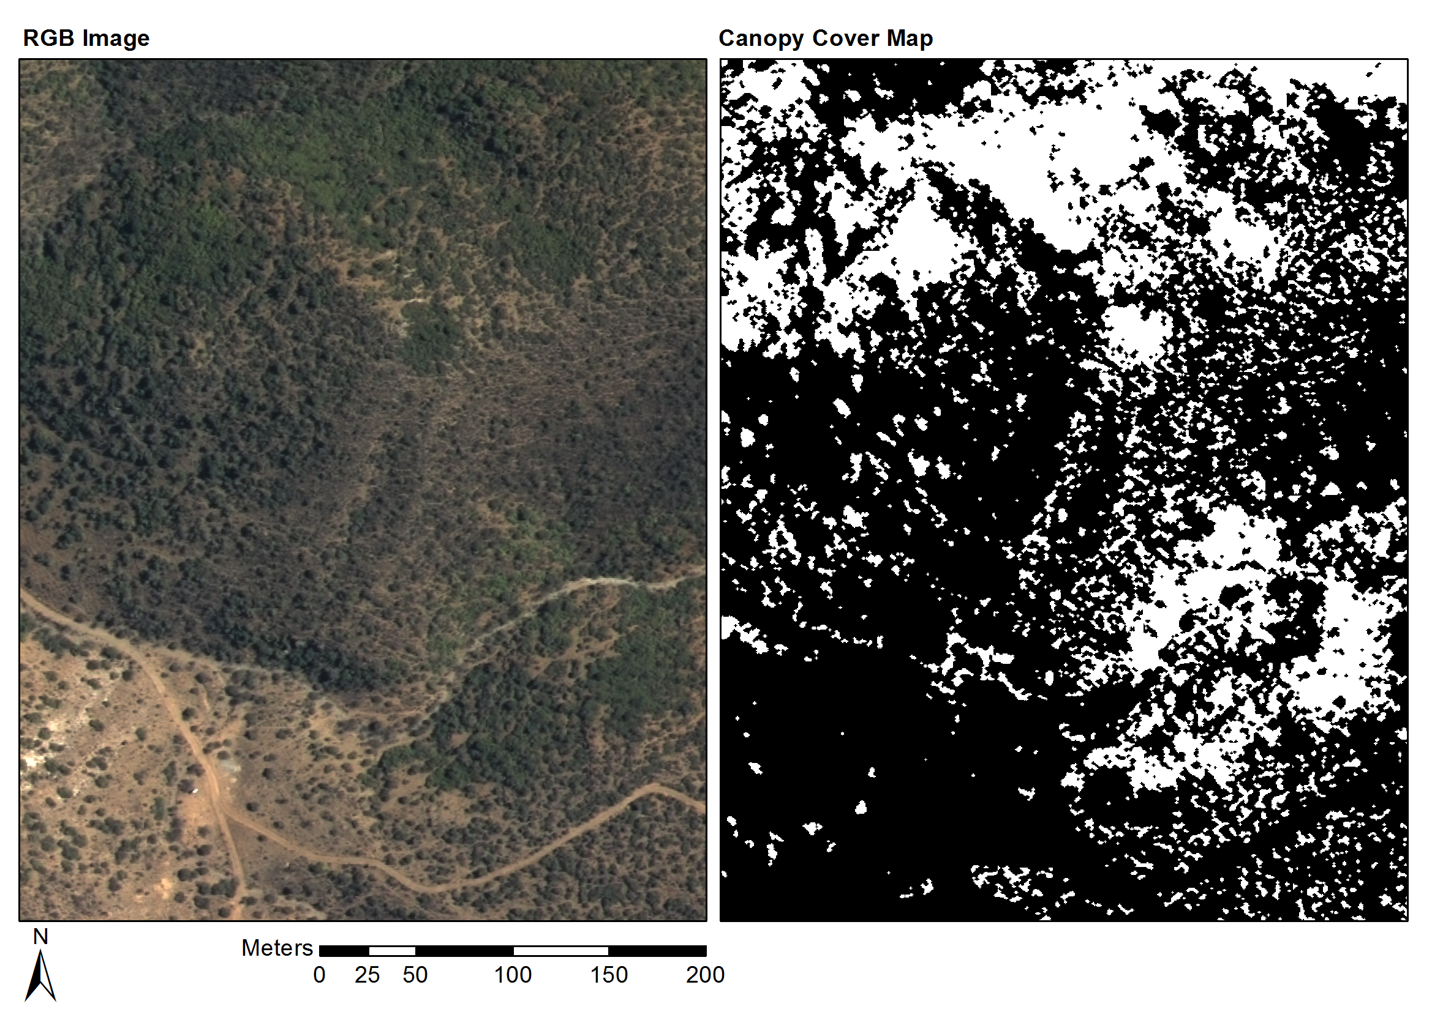

Figure 6 Groenfontein classification (Habitat: valley thicket with Spekboom)

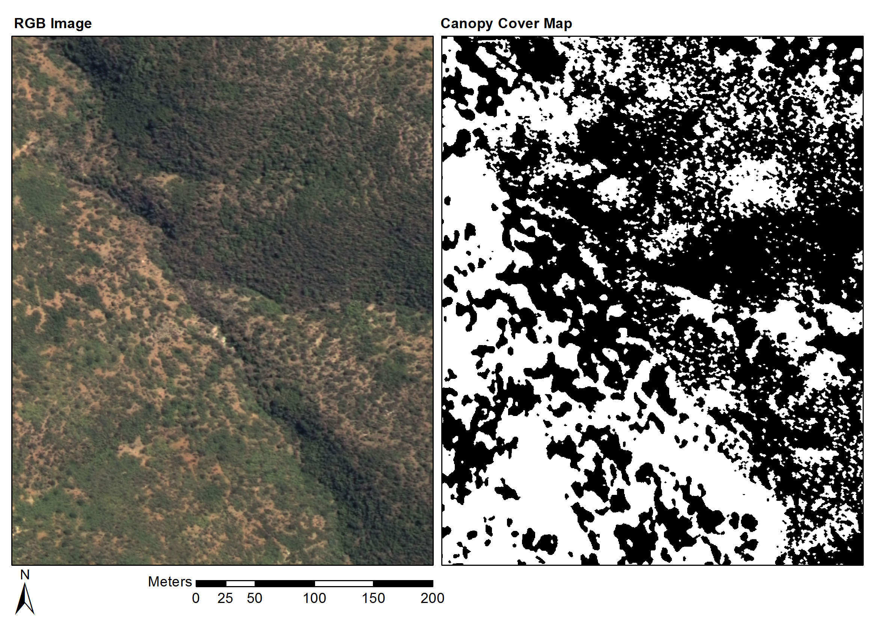

Figure 7 Matjiesvlei classification (Habitat: arid thicket with Spekboom)

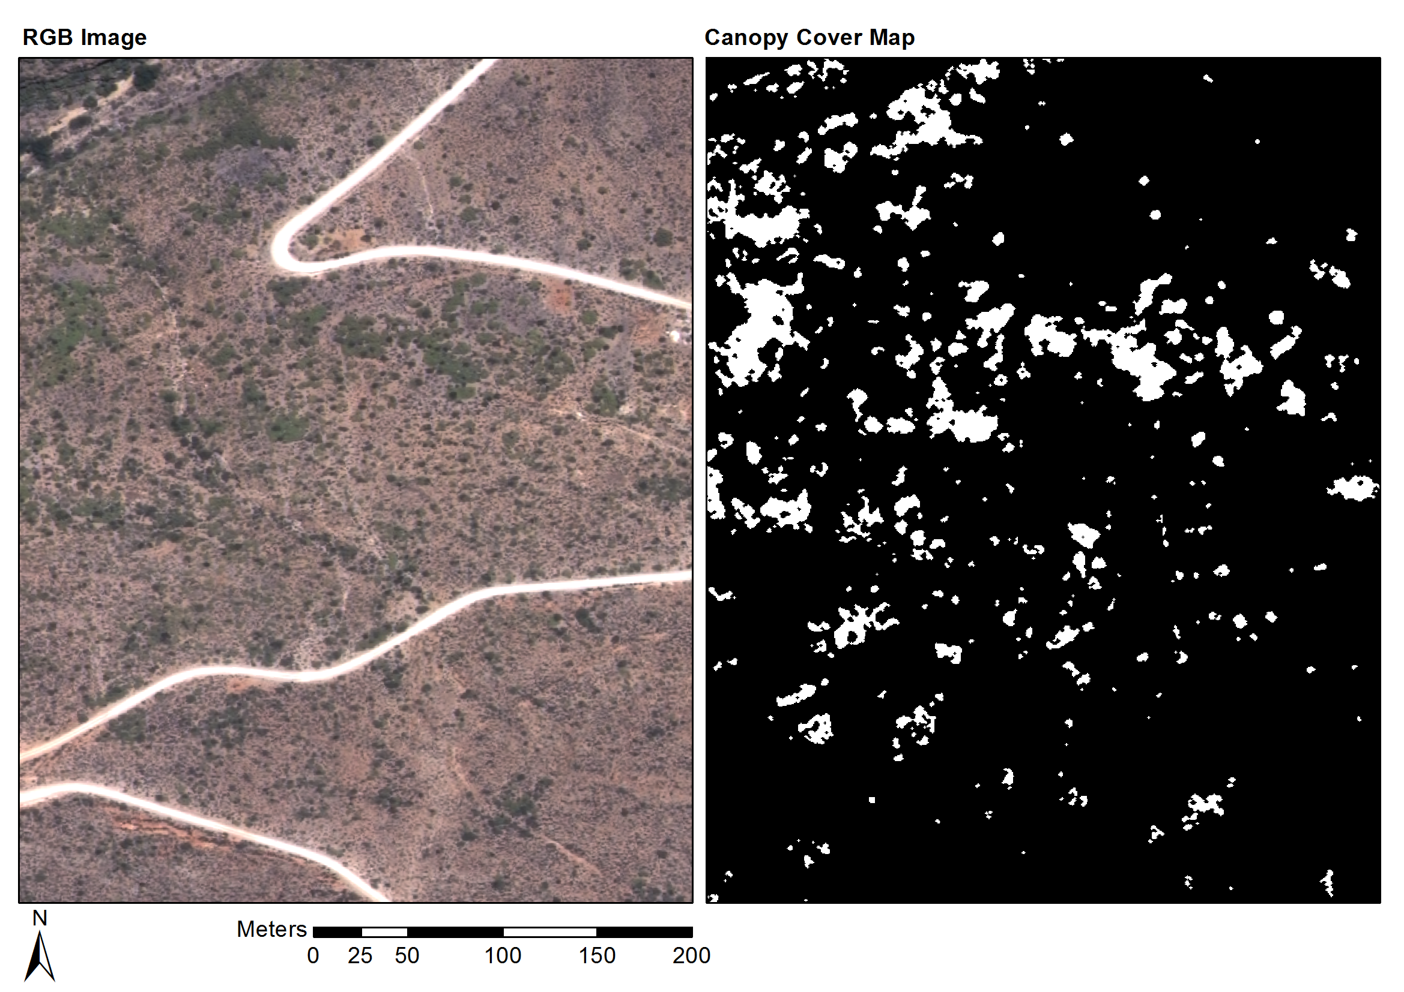

Figure 8 Rooiberg classification (Habitat: arid thicket with Spekboom and Fynbos mosaic)

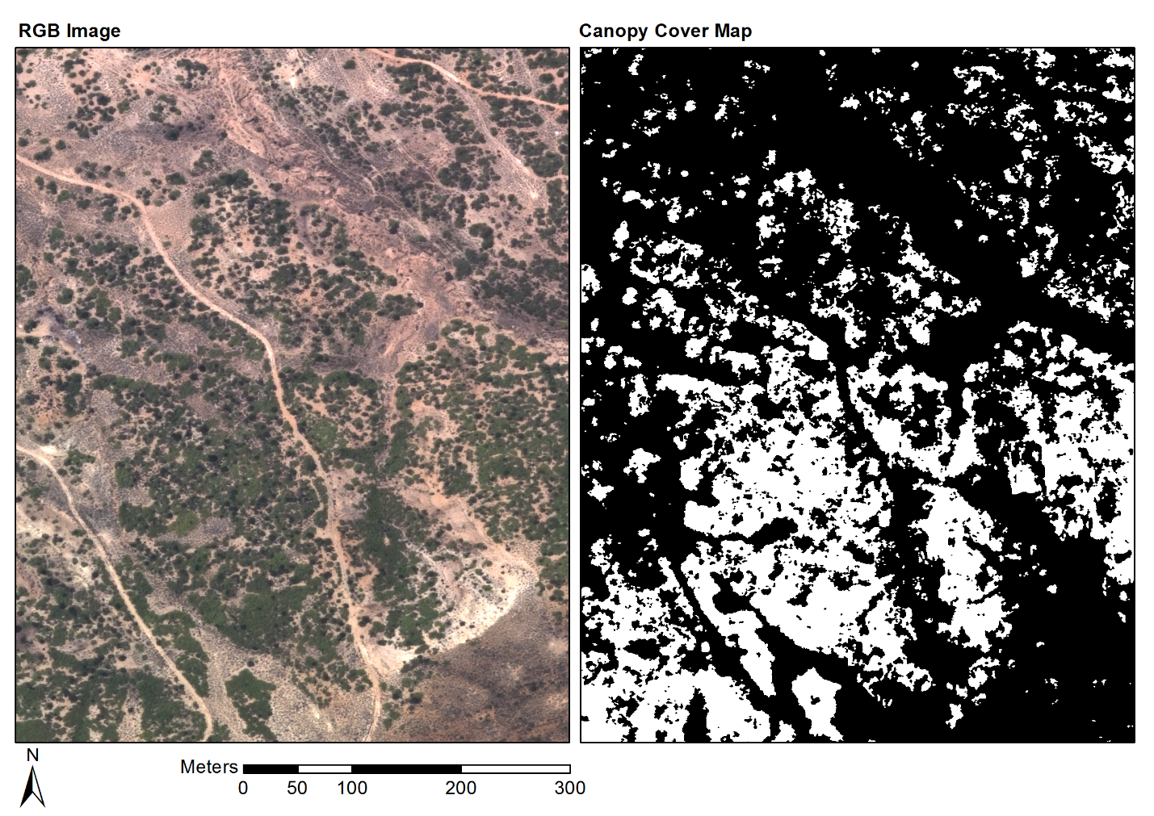

Figure 9 Grootkop classification (Habitat: arid thicket with Spekboom and Succulent Karoo mosaic)

# Conclusions

The per-pixel classification approach to Spekboom canopy cover mapping was successful and good accuracies were achieved across the study area. Use of the technique for extraction of surface reflectance by calibration with satellite data (described in Chapter 2) was key in obtaining the radiometric consistency required to allow application of a single classification algorithm over an extended area. Six features, consisting of a combination of spectral, textural and vegetation index type measures, were selected with the feature clustering and ranking method described in Chapter 3. The feature set produced similarly good accuracies amongst a diverse set of candidate classifiers, confirming the feature selection method’s utility for finding informative features in the presence of redundancy. A decision tree classifier was selected from the candidate classifiers due to its speed and accuracy on the field ground truth. Attention to the computational efficiency of feature extraction and classification methods assisted in being able to effectively experiment with and process large volumes of images. The classifier produced a mean absolute canopy cover error of 5.86% and standard deviation of 4.85% over the 20 field ground truth sites.

While some variation in the classification accuracy was observed with habitat, the classifier was remarkably robust to the many sources of variation that make this a challenging problem. To the best of our knowledge, this is the first use of a mosaic of NGI aerial imagery in a quantitative remote sensing study. It is also one of very few examples of vegetation mapping using VHR imagery over a large area (Eisfelder et al., 2012; Lu, 2006). The availability of a vegetation map covering the study area (Vlok et al., 2005) and the assistance of an expert botanist in selecting and ground truthing the field sites were important contributors to the success of this study.

The map as it stands will provide a useful aid in selecting restoration sites and in choosing appropriate planting densities in the study area. By incorporating ground truth from new areas, the techniques used to produce this map could be extended to the rest of the thicket biome in the Little Karoo and Eastern Cape, where restoration work is also under way (Mills et al., 2010). The availability of a Spekboom canopy cover map will also be a valuable starting point for developing measures of other environmental variables such as biomass and biodiversity (Eisfelder et al., 2012; Ludwig et al., 1975; Suganuma et al., 2006).

While the mapping accuracies achieved compare well with related studies (Baraldi et al., 2010; Ghosh and Joshi, 2014; Heumann, 2011; Johansen et al., 2007; Mehner et al., 2004), there are possible avenues for improvement. Acquisition of further field ground truth would allow for a more comprehensive validation of the technique. Ancillary information such as slope aspect or habitat could be incorporated into the classifier, similarly to Thompson et al. (2009). This could be done by including it either as a feature or by designing separate classifiers for different ranges or categories of the ancillary variable. While spatial context was included in our classifier through the sliding window features and morphological post processing, texture information could be better exploited by following an object based approach (Blaschke, 2010). Homogenous objects would allow the use of more descriptive texture features such as LBP’s and statistics of the GLCM.

# Acknowledgement

We would like to thank Adrian Roos and Intergraph South Africa for providing a license for Intergraph PPS, Bernard Jacobs of Geospace International for assistance in understanding the NGI image processing workflow and in obtaining DMC relative spectral response data, Theo Pauw and Garth Stephenson of CGA for assistance with computing and software resources and Julie Verhulp and NGI for provision of the aerial imagery. The financial assistance of the National Research Foundation (NRF) towards this research is hereby acknowledged. Opinions expressed and conclusions arrived at, are those of the author and are not necessarily to be attributed to the NRF. Lastly, we are grateful for funding from the Gamtoos Irrigation Board (GIB). GIB was otherwise not involved in this research.

REFERENCES

Adie, H., Yeaton, R.I., 2013. Regeneration dynamics in arid subtropical thicket, South Africa. South African Journal of Botany 88, 80–85. doi:10.1016/j.sajb.2013.05.010

Amorós López, J., Izquierdo Verdiguier, E., Gómez Chova, L., Muñoz Marí, J., Rodríguez Barreiro, J.Z., Camps Valls, G., Calpe Maravilla, J., 2011. Land cover classification of VHR airborne images for citrus grove identification. ISPRS Journal of Photogrammetry and Remote Sensing 66, 115–123. doi:10.1016/j.isprsjprs.2010.09.008

Baraldi, A., Durieux, L., Simonetti, D., Conchedda, G., Holecz, F., Blonda, P., 2010. Automatic spectral-rule-based preliminary classification of radiometrically calibrated SPOT-4/-5/IRS, AVHRR/MSG, AATSR, IKONOS/QuickBird/OrbView/GeoEye, and DMC/SPOT-1/-2 imagery—Part I: System design and implementation. IEEE Transactions on Geoscience and Remote Sensing 48, 1299–1325.

Basu, S., Ganguly, S., Nemani, R.R., Mukhopadhyay, S., Zhang, G., Milesi, C., Michaelis, A., Votava, P., Dubayah, R., Duncanson, L., Cook, B., Yu, Y., Saatchi, S., DiBiano, R., Karki, M., Boyda, E., Kumar, U., Li, S., 2015. A Semiautomated Probabilistic Framework for Tree-Cover Delineation From 1-m NAIP Imagery Using a High-Performance Computing Architecture. IEEE Transactions on Geoscience and Remote Sensing 53, 5690–5708. doi:10.1109/TGRS.2015.2428197

Bishop, C.M., 2003. Neural networks for pattern recognition. Oxford University Press, New York. doi:10.1002/0470854774

Blaschke, T., 2010. Object based image analysis for remote sensing. ISPRS Journal of Photogrammetry and Remote Sensing 65, 2–16. doi:10.1016/j.isprsjprs.2009.06.004

Blauensteiner, P., Wildenauer, H., Hanbury, A., Kampel, M., 2006. On colour spaces for change detection and shadow suppression, in: Chum, O., Franc, V. (Eds.), Computer Vision Winter Workshop 2006. Czech Pattern Recognition Society, Telc, Czech Republic, pp. 1–6.

Boyden, J., Walden, D., Bartolo, R., Bayliss, P., Division, S.S., Territory, N., 2007. Utility of VHR remote sensing data for landscape scale assessment of the environmental weed para grass [UROCHLOA MUTICA, (FORSSK), NGUYEN] on a tropical floodplain, in: 28th Asian Conference on Remote Sensing 2007, ACRS 2007. pp. 551–556.

Bradski, G., 2000. The OpenCV library. Dr. Dobb’s Journal of Software Tools 25, 122–125.

Breiman, L., 2001. Random Forests. Machine Learning 45, 5–32. doi:10.1023/A:1010933404324

Breiman, L., 1996. Bagging predictors. Machine Learning 24, 123–140.

Breiman, L., Friedman, J., Olshen, R., Stone, C., 1984. Classification and regression trees. Wadsworth, Calif.

Burges, C.J.C., 1998. A tutorial on support vector machines for pattern recognition. Data Mining and Knowledge Discovery 2, 121–167. doi:10.1023/A:1009715923555

Curran, P., Smedley, D., Thompson, P., Knight, A.T., 2012. Mapping restoration opportunity for collaborating with land managers in a carbon credit-funded restoration program in the Makana municipality, Eastern Cape, South Africa. Restoration Ecology 20, 56–64. doi:10.1111/j.1526-100X.2010.00746.x

de Castro, A.I., Jurado-Expósito, M., Peña-Barragán, J.M., López-Granados, F., 2012. Airborne multi-spectral imagery for mapping cruciferous weeds in cereal and legume crops. Precision Agriculture 13, 302–321. doi:10.1007/s11119-011-9247-0

Duin, R.P.W., Tax, D.M.J., 2005. Statistical Pattern Recognition, in: Chen, C., Wang, P. (Eds.), Handbook of Pattern Recognition and Computer Vision, 3rd Ed. World Scientific, Singapore, pp. 1–21. doi:10.1142/9789812775320_0001

Eisfelder, C., Kuenzer, C., Dech, S., 2012. Derivation of biomass information for semi-arid areas using remote-sensing data. International Journal of Remote Sensing 33, 2937–2984.

Gates, D.M., 1980. Biophysical Ecology, Springer Advanced Texts in Life Sciences. Springer, New York. doi:10.1007/978-1-4612-6024-0

Ghosh, A., Joshi, P.K., 2014. A comparison of selected classification algorithms for mapping bamboo patches in lower Gangetic plains using very high resolution WorldView 2 imagery. International Journal of Applied Earth Observation and Geoinformation 26, 298–311. doi:10.1016/j.jag.2013.08.011

Hand, D.J., Yu, K., 2001. Idiot’s Bayes - not so stupid after all? International Statisitical Review 69, 385–398.

Heumann, B.W., 2011. Satellite remote sensing of mangrove forests: Recent advances and future opportunities. Progress in Physical Geography 35, 87–108. doi:10.1177/0309133310385371

Intergraph, 2008. Digital mapping camera system [WWW Document]. URL http://www.geospace.co.za/pdf/DMC Brochure.pdf

Jain, A.K., Duin, R.P.W., Mao, J., 2000. Statistical pattern recognition: a review. IEEE Transactions on Pattern Analysis and Machine Intelligence 22, 4–37.

Johansen, K., Coops, N.C., Gergel, S.E., Stange, Y., 2007. Application of high spatial resolution satellite imagery for riparian and forest ecosystem classification. Remote Sensing of Environment 110, 29–44. doi:10.1016/j.rse.2007.02.014

Kauth, R.J., Thomas, G.S., 1976. The tasselled cap -- a graphic description of the spectral-temporal development of agricultural crops as seen by LANDSAT, in: Symposium on Machine Processing of Remotely Sensed Data. IEEE, Purdue University of West Lafayette, Indiana, USA, p. 4B41-4B51.

Key, T., Warner, T.A., McGraw, J.B., Fajvan, M.A., 2001. A comparison of multispectral and multitemporal information in high spatial resolution imagery for classification of individual tree species in a temperate hardwood forest. Remote Sensing of Environment 75, 100–112.

Kollár, S., Vekerdy, Z., Márkus, B., 2013. Aerial image classification for the mapping of riparian vegetation habitats. Acta Silvatica et Lignaria Hungarica 9, 119–133. doi:10.2478/aslh-2013-0010

Lechmere-Oertel, R.G., Kerley, G., Mills, A.J., Cowling, R.M., 2008. Litter dynamics across browsing-induced fenceline contrasts in succulent thicket, South Africa. South African Journal of Botany 74, 651–659. doi:10.1016/j.sajb.2008.04.002

Li, Z., Hayward, R.F., Zhang, J., Jin, H., Walker, R.A., 2010. Evaluation of spectral and texture features for object-based vegetation species classification using support vector machines, in: Wagner, W., Székely, B. (Eds.), ISPRS TC VII Symposium – 100 Years ISPRS. IAPRS, Vienna, Austria, pp. 122–127.

Lu, D., 2006. The potential and challenge of remote sensing based biomass estimation. International Journal of Remote Sensing 27, 1297–1328. doi:10.1080/01431160500486732

Ludwig, J.A., Reynolds, J.F., Whitson, P.D., 1975. Size-biomass relationships of several Chihuahuan desert shrubs. American Midland Naturalist 94, 451–461.

Marais, C., Cowling, R.M., Powell, M., 2009. Establishing the platform for a carbon sequestration market in South Africa: The Working for Woodlands Subtropical Thicket Restoration Programme, in: XIII World Forestry Congress. Buenos Aires, Argentina, pp. 1–13.

Mehner, H., Cutler, M., Fairbairn, D., Thompson, G., 2004. Remote sensing of upland vegetation: the potential of high spatial resolution satellite sensors. Global Ecology and Biogeography 13, 359–369. doi:10.1111/j.1466-822X.2004.00096.x

Mills, A.J., Blignaut, J., Cowling, R.M., Knipe, A., Marais, C., Marais, S., Pierce, S., Powell, M., Sigwela, A., Skowno, A., 2010. Investing in sustainability. Restoring degraded thicket, creating jobs, capturing carbon and earning green credit., Published by Climate Action Partnership, Cape Town, and Wilderness Foundation, Port Elizabeth, Series. Climate Action Partnership, Cape Town and Wilderness Foundation, Port Elizabeth.

Mills, A.J., Cowling, R.M., 2010. Below-ground carbon stocks in intact and transformed subtropical thicket landscapes in semi-arid South Africa. Journal of Arid Environments 74, 93–100. doi:10.1016/j.jaridenv.2009.07.002

Mills, A.J., Cowling, R.M., 2006. Rate of carbon sequestration at two thicket restoration sites in the Eastern Cape, South Africa. Restoration Ecology 14, 38–49.

Mills, A.J., Cowling, R.M., Fey, M., Kerley, G., Donaldson, J., Sigwela, A., Skowno, A., Rundel, P., 2005. Effects of goat pastoralism on ecosystem carbon storage in semiarid thicket, Eastern Cape, South Africa. Austral Ecology 30, 797–804.

Mills, A.J., Fey, M., 2004. Transformation of thicket to savanna reduces soil quality in the Eastern Cape, South Africa. Plant and Soil 265, 153–163. doi:10.1007/s11104-005-0534-2

Mills, A.J., Turpie, J.K., Cowling, R.M., Marais, C., Kerley, G., Richard, G., Sigwela, A., Powell, M., 2007. Assessing costs, benefits, and feasibility of restoring natural capital in Subtropical Thicket in South Africa, in: Aronson, J., Milton, S., Blignaut, J. (Eds.), Restoring Natural Capital: Science, Business and Practice (The Science and Practice of Ecological Restoration Series). Island Press., Washington DC, pp. 179–187.

Mingguo, Z., Qianguo, C., Mingzhou, Q., 2009. The Effect of Prior Probabilities in the Maximum Likelihood Classification on Individual Classes. Photogrammetric Engineering & Remote Sensing, IGARSS 2005 held 25-29 July 75, 1109–1117. doi:10.14358/PERS.75.9.1109

Mustafa, Y.T., Habeeb, H.N., 2014. Object based technique for delineating and mapping 15 tree species using VHR WorldView-2 imagery, in: Proc. SPIE. p. 92390G–92390G–13. doi:10.1117/12.2067280

Myneni, R.B., Hall, F.G., Sellers, P.J., Marshak, A.L., 1995. The interpretation of spectral vegetation indexes. IEEE Transactions on Geoscience and Remote Sensing 33, 481–486. doi:10.1109/36.377948

OpenCV Development Team, 2014. OpenCV documentation [WWW Document]. Open Source Computer Vision Library. URL http://docs.opencv.org/

Ouyang, Z.-T., Zhang, M.-Q., Xie, X., Shen, Q., Guo, H.-Q., Zhao, B., 2011. A comparison of pixel-based and object-oriented approaches to VHR imagery for mapping saltmarsh plants. Ecological Informatics 6, 136–146. doi:10.1016/j.ecoinf.2011.01.002

Powell, M.J., 2009. Restoration of degraded subtropical thickets in the Baviaanskloof Megareserve, South Africa (No. MSc. thesis), Series. Master’s thesis. Grahamstown: Rhodes University, Department of Environmental Science.

Sahu, B., Mishra, D., 2011. A novel approach for selecting informative genes from gene expression data using signal-to-noise ratio and t-statistics, in: 2011 2nd International Conference on Computer and Communication Technology (ICCCT-2011). IEEE, Allahabad, India, pp. 5–10. doi:10.1109/ICCCT.2011.6075207

Serra, J., Soille, P. (Eds.), 1994. Mathematical morphology and its applications to image processing, in: 2nd International Symposium on Mathematical Morphology (ISMM’94), Computational Imaging and Vision. Kluwer Academic Publishers, p. 383.

Sigwela, A., Kerley, G., Mills, A.J., Cowling, R.M., 2009. The impact of browsing-induced degradation on the reproduction of subtropical thicket canopy shrubs and trees. South African Journal of Botany 75, 262–267. doi:10.1016/j.sajb.2008.12.001

Singh, M., Malhi, Y., Bhagwat, S., 2014. Biomass estimation of mixed forest landscape using a Fourier transform texture-based approach on very-high-resolution optical satellite imagery. International Journal of Remote Sensing 35, 3331–3349. doi:10.1080/01431161.2014.903441

Strobl, C., Boulesteix, A.-L., Kneib, T., Augustin, T., Zeileis, A., 2008. Conditional variable importance for random forests. BMC bioinformatics 9, 307. doi:10.1186/1471-2105-9-307

Suganuma, H., Abe, Y., Taniguchi, M., Tanouchi, H., Utsugi, H., Kojima, T., Yamada, K., 2006. Stand biomass estimation method by canopy coverage for application to remote sensing in an arid area of Western Australia. Forest Ecology and Management 222, 75–87. doi:10.1016/j.foreco.2005.10.014

Szekely, G.J., Rizzo, M.L., 2005. Hierarchical clustering via joint between-within distances: extending Ward’s minimum variance method. Journal of Classification 22, 151–183. doi:10.1007/s00357-005-0012-9

Thompson, M., Vlok, J., Rouget, M., Hoffman, M.T., Cowling, R.M., 2009. Mapping grazing-induced degradation in a semi-arid environment: A rapid and cost effective approach for assessment and monitoring. Environmental Management 43, 585–596. doi:10.1007/s00267-008-9228-x

Thompson, M.W., Vlok, J., Cowling, R.M., Cundill, S.L., Mudau, N., 2005. A land transformation map of the Little Karoo, CEPF Funded Project. GeoterraImage, Pretoria.

Tolosi, L., Lengauer, T., 2011. Classification with correlated features: unreliability of feature ranking and solutions. Bioinformatics 27, 1986–1994. doi:10.1093/bioinformatics/btr300

Trias-Sanz, R., Stamon, G., Louchet, J., 2008. Using colour, texture, and hierarchial segmentation for high-resolution remote sensing. ISPRS Journal of Photogrammetry and Remote Sensing 63, 156–168. doi:10.1016/j.isprsjprs.2007.08.005

Trimble, 2016. eCognition Developer user guide.

van der Vyver, M.L., Cowling, R.M., Mills, A.J., Difford, M., 2013. Spontaneous return of biodiversity in restored subtropical thicket: Portulacaria afra as an ecosystem engineer. Restoration Ecology 21, 736–744. doi:10.1111/rec.12000

van Luijk, G., Cowling, R.M., Riksen, M.J.P.M., Glenday, J., 2013. Hydrological implications of desertification: Degradation of South African semi-arid subtropical thicket. Journal of Arid Environments 91, 14–21. doi:10.1016/j.jaridenv.2012.10.022

Vlok, J., Cowling, R.M., Wolf, T., 2005. A vegetation map for the Little Karoo. Unpublished maps and report for a SKEP project supported by CEPF grant no 1064410304.

Vyver, M.L., Cowling, R.M., Campbell, E.E., Difford, M., 2012. Active restoration of woody canopy dominants in degraded South African semi-arid thicket is neither ecologically nor economically feasible. Applied Vegetation Science 15, 26–34. doi:10.1111/j.1654-109X.2011.01162.x

Xu, M., Watanachaturaporn, P., Varshney, P., Arora, M., 2005. Decision tree regression for soft classification of remote sensing data. Remote Sensing of Environment 97, 322–336. doi:10.1016/j.rse.2005.05.008

Yousef, M., Jung, S., Showe, L.C., Showe, M.K., 2007. Recursive cluster elimination (RCE) for classification and feature selection from gene expression data. BMC Bioinformatics 8. doi:10.1186/1471-2105-8-144